**Cluster Agent Installation**

Copied the zip file and unzip it on the cluster

1. Download the latest cluster agent from download.appdynamics.com

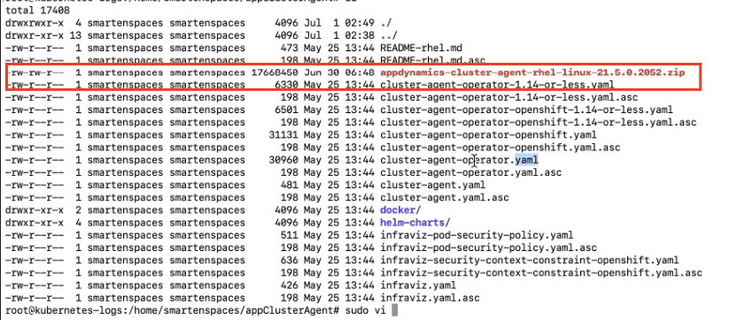

1. Create the namespace appdynamics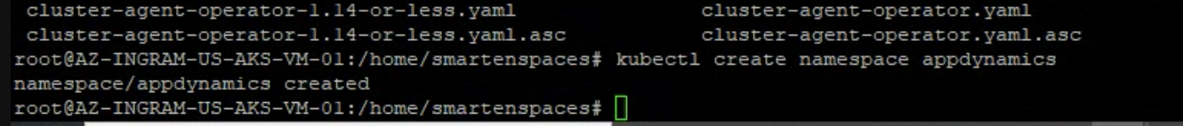
2. Create the cluster-agent-operator.yaml file



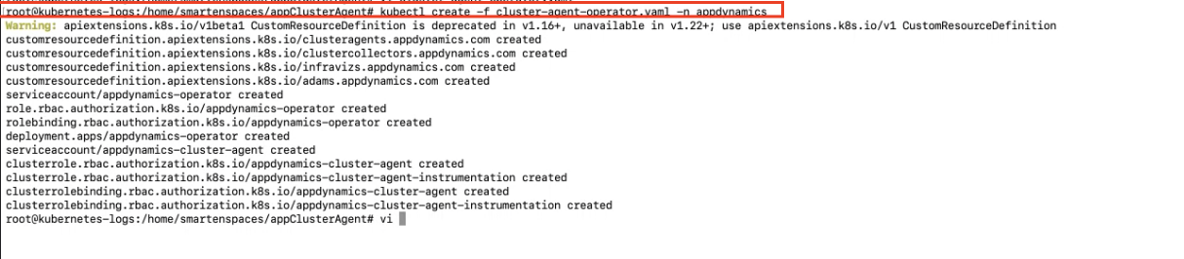

1. Run the secret key generation command

kubectl -n appdynamics create secret generic cluster-agent-secret --from-literal=controller-key=k5ptdobjjm3x



1. Making changes in the Cluster-agent.yaml file

namespace: appdynamics

appName: ""

ControllerURl

Account:

DefaultAppName <this comes in Application Dashboard>

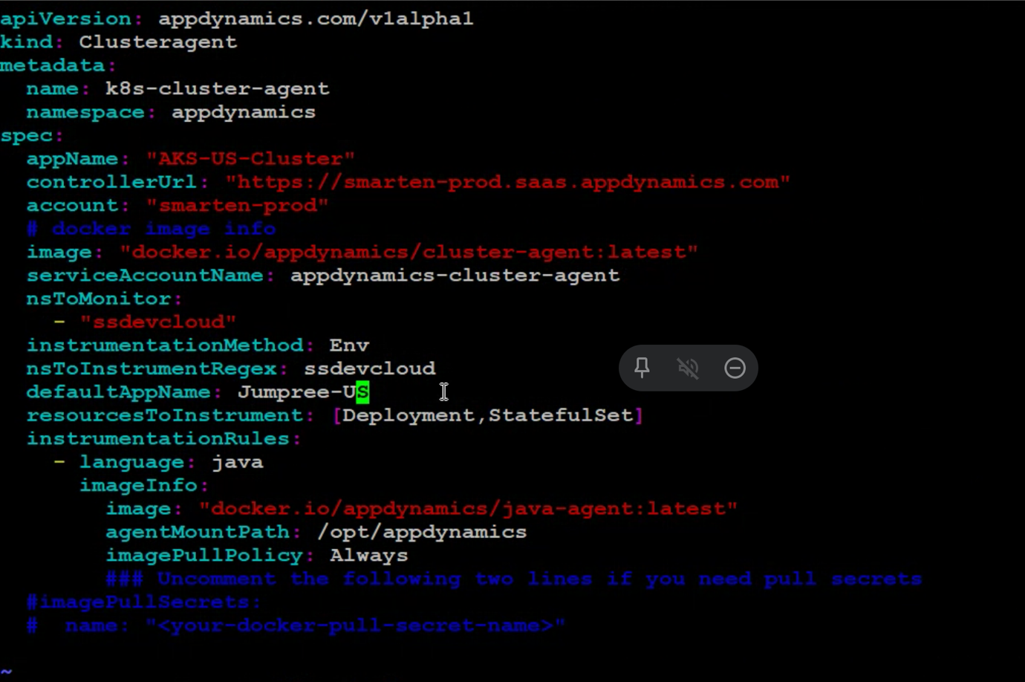

1. Create the cluster agent

kubectl create -f cluster-agent.yaml

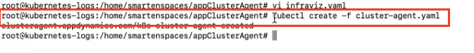

1. To check if the appdynamics java agent is deployed correctly, run the below command.

kubectl describe pod <pod name> -n ssdevcloud

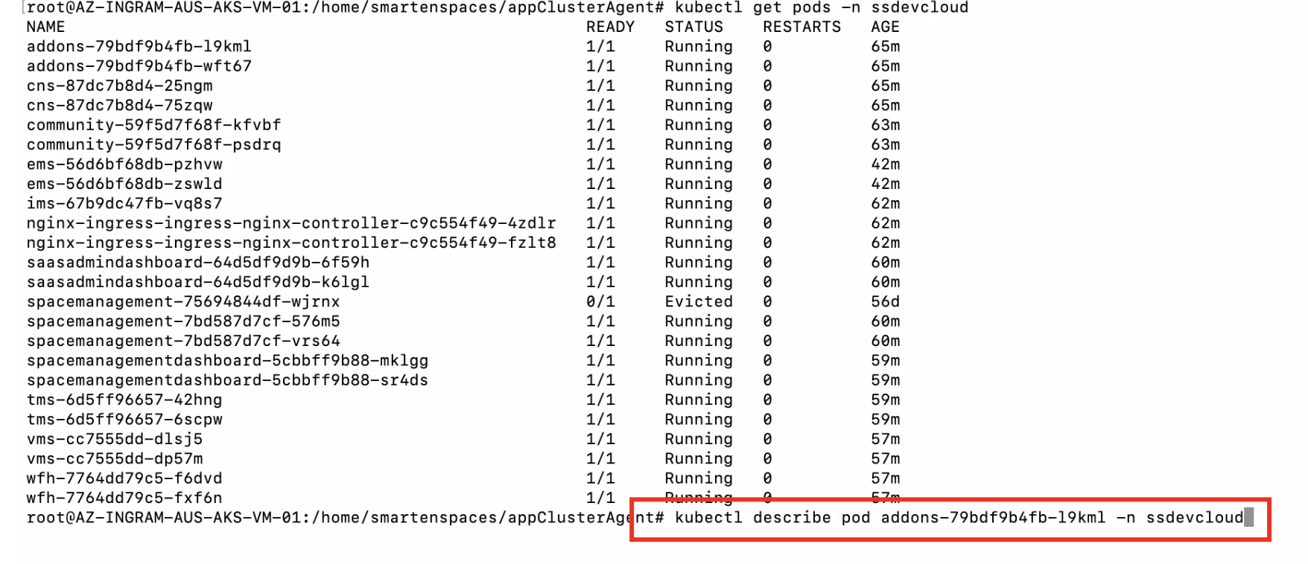

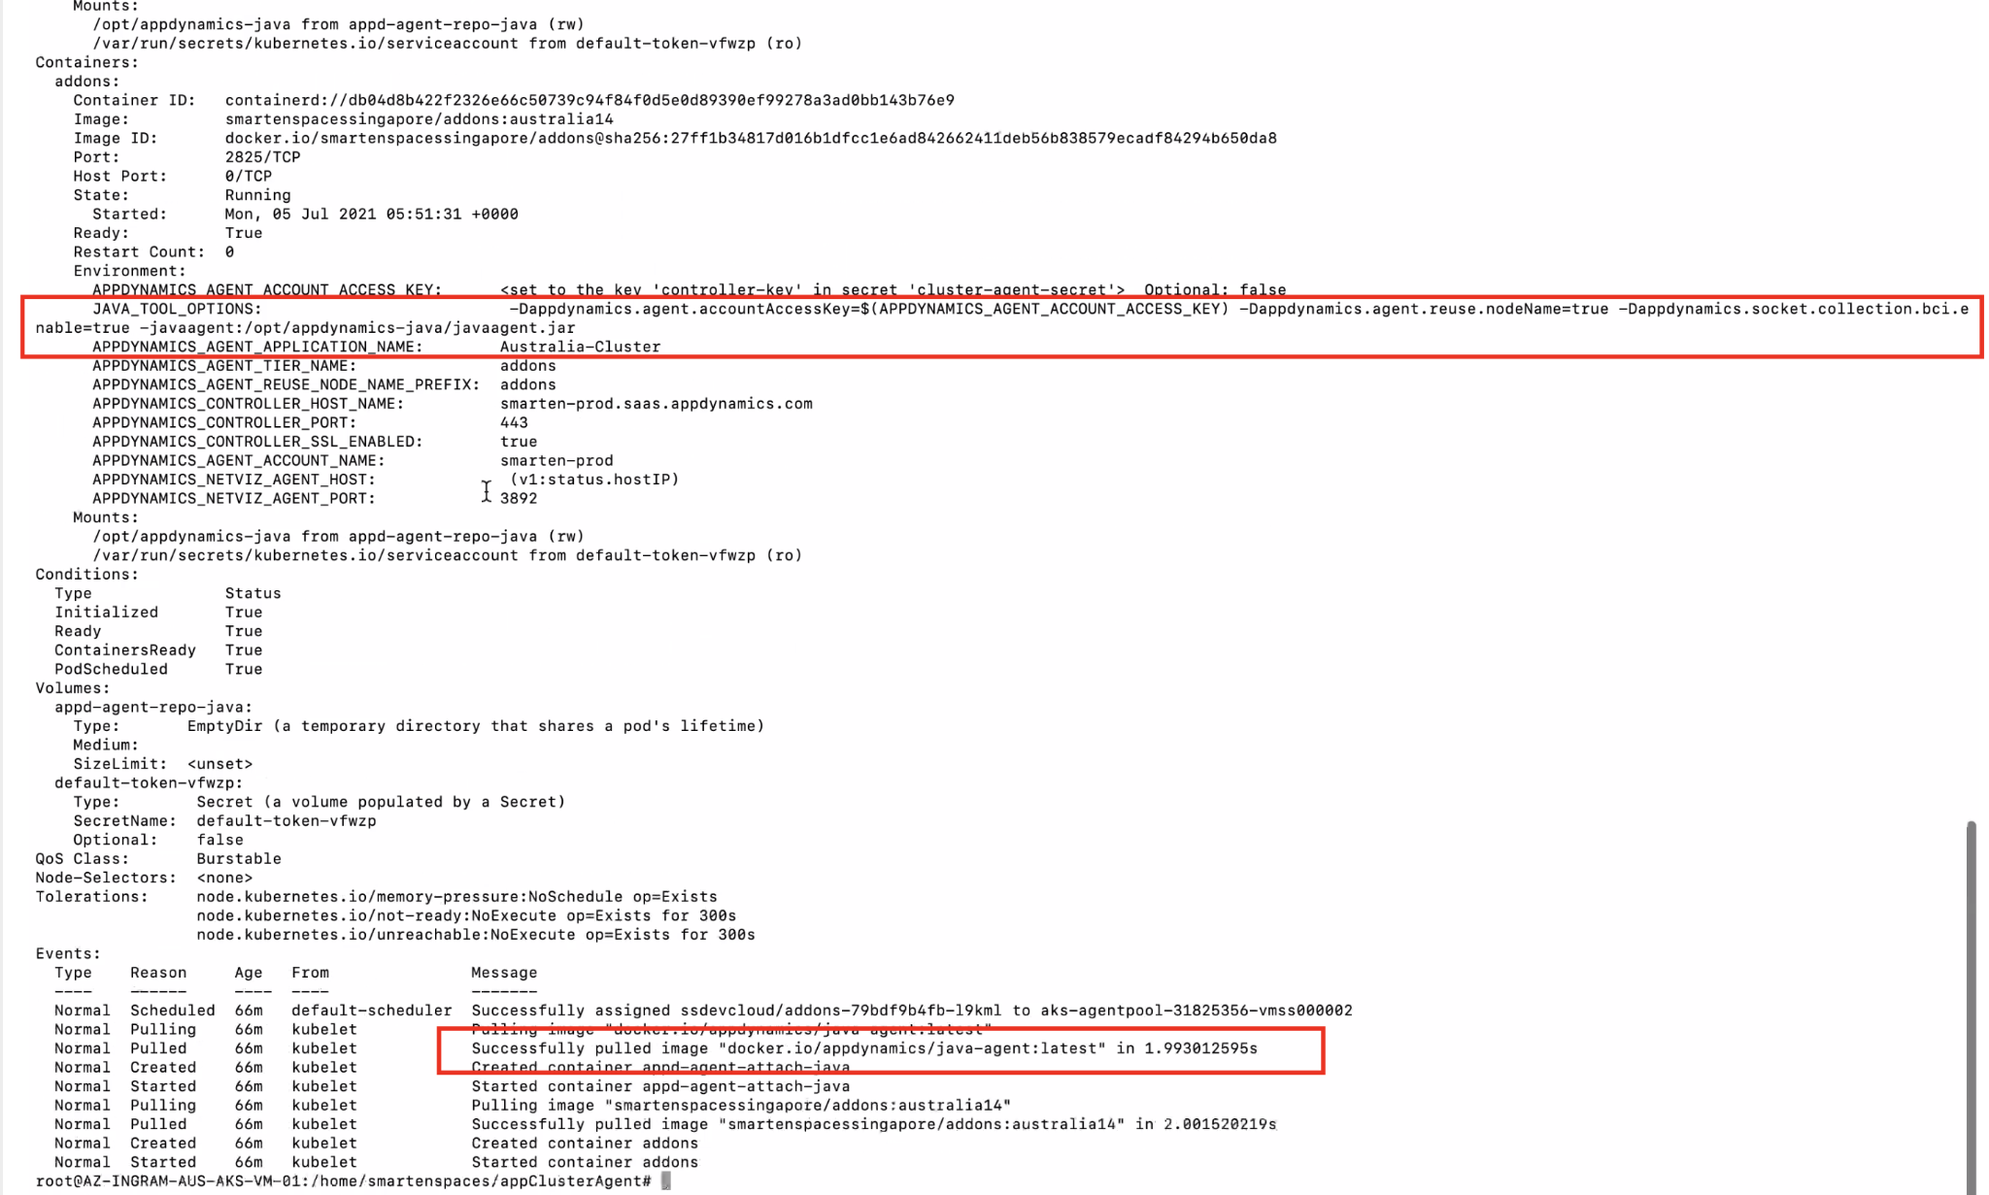

**Install Infraviz - Network and Machine Agent**

1. Update the infraviz.yaml file as shown below:

apiVersion: v1

kind: ServiceAccount

metadata:

name: appdynamics-infraviz

namespace: appdynamics

---

apiVersion: [appdynamics.com/v1alpha1](http://appdynamics.com/v1alpha1)

kind: InfraViz

metadata:

name: appd-infraviz

namespace: appdynamics

spec:

#controllerUrl: "http://<appdynamics-controller-host>:8080"

controllerUrl: "[https://smarten-prod.saas.appdynamics.com](https://smarten-prod.saas.appdynamics.com/)"

image: "[docker.io/appdynamics/machine-agent-analytics:latest](http://docker.io/appdynamics/machine-agent-analytics:latest)"

account: "smarten-prod"

globalAccount: "smarten-prod_bafdb30f-bc5d-48f7-b22f-95fa8cba8113"

enableServerViz: "true"

netVizImage: [appdynamics/machine-agent-netviz:latest](http://docker.io/appdynamics/machine-agent-netviz:latest)

netVizPort: 3892

resources:

limits:

cpu: 500m

memory: "1G"

requests:

cpu: 200m

memory: "800M"

1. Run the create command

kubectl create -f infraviz.yaml



1. Verify the pods are running

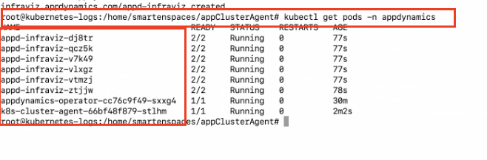

1. Run this command on the pods to check if machine agent is installed successfully

kubectl -n appdynamics logs appd-infraviz-shkhj -c appd-infra-agent

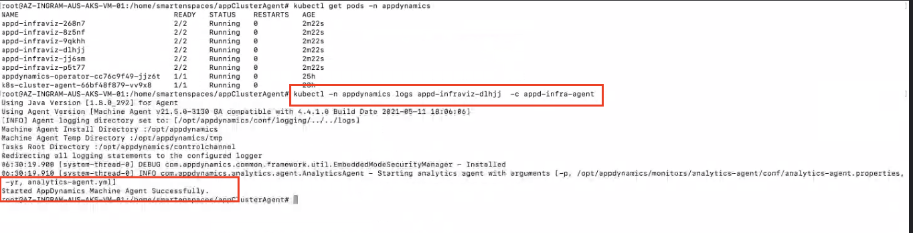

**Uninstall the cluster agent using Kubernetes CLI**

1. Disable the auto-instrumentation
2. To completely disable auto-instrumentation, set the instrumentationMethod to None
3. Run the below command to apply the settings

kubectl apply -f cluster-agent.yaml

1. Wait till the java agent is completely disabled from the UI.

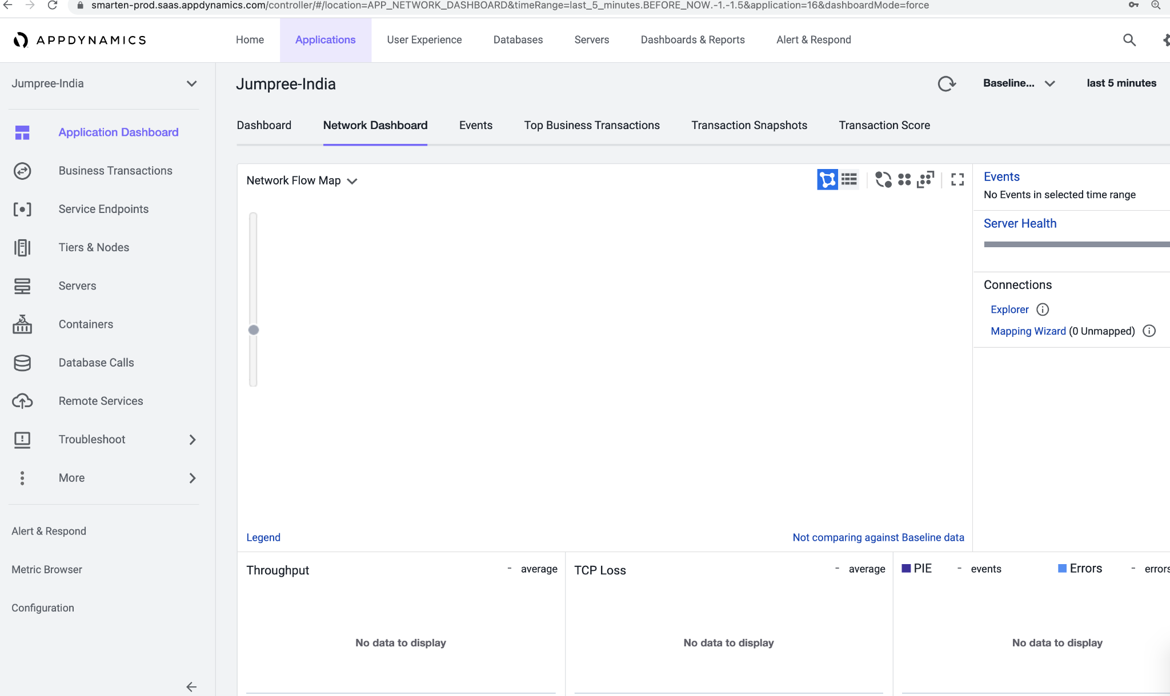

1. Ensure the tiers and nodes are showing 0% App Agent

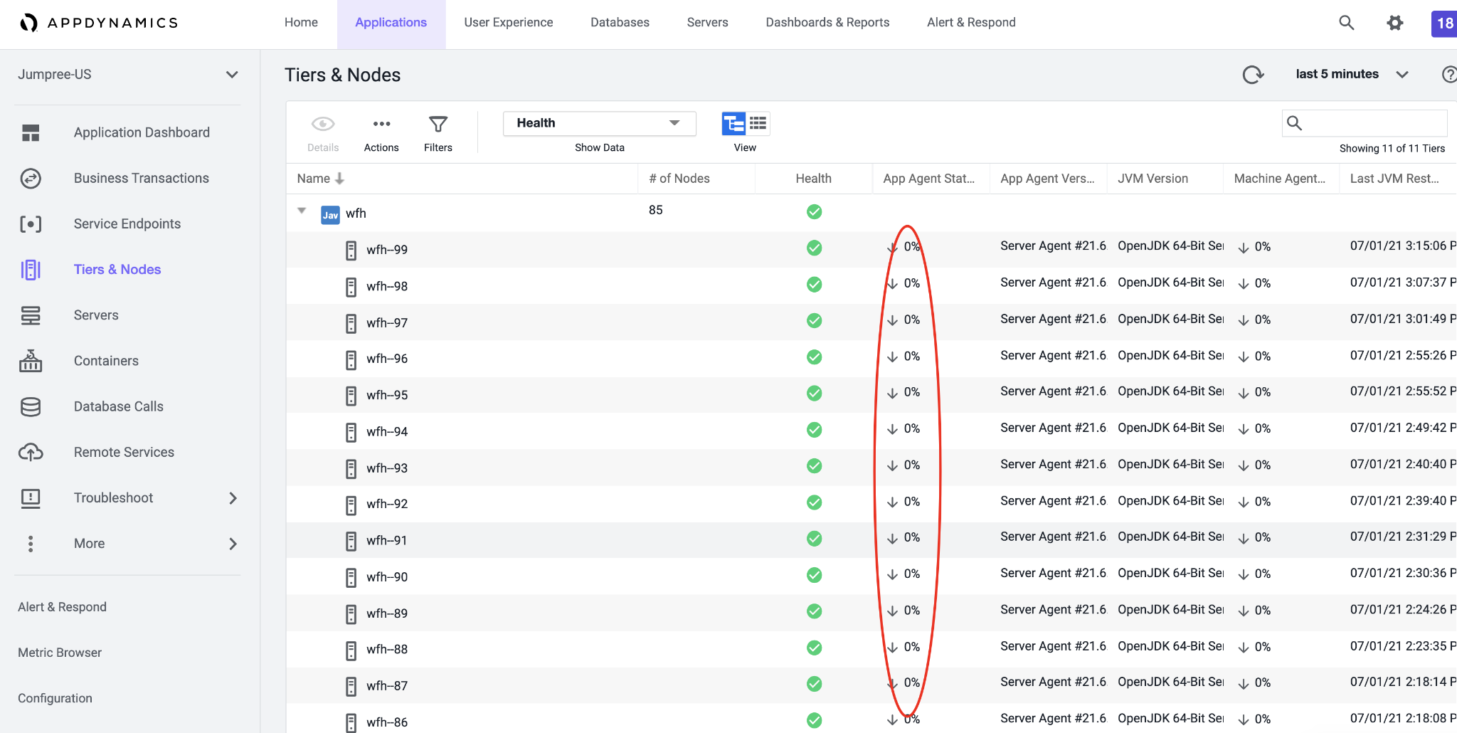

1. After this run the below command on the cluster.

kubectl delete -f cluster-agent.yaml

kubectl delete -f cluster-agent-operator.yaml

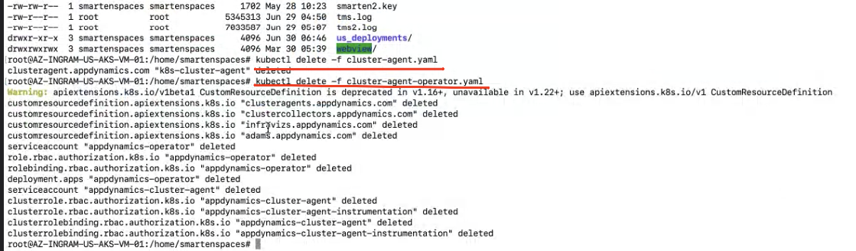

1. Check the cluster agent in controller UI

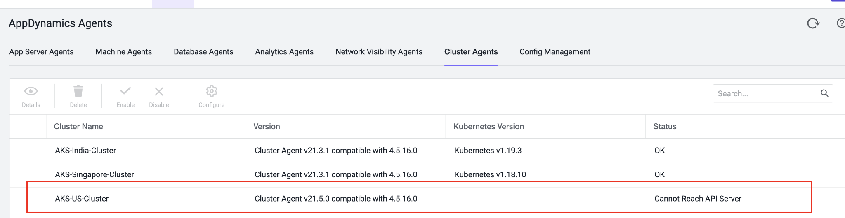

1. Check under Servers > Clusters

